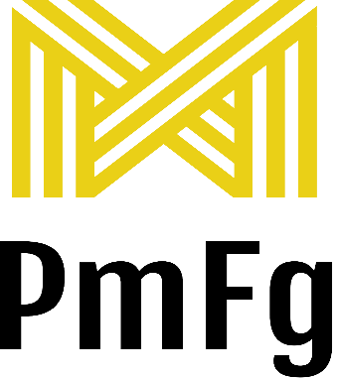


ENVIRONMENTAL SUSTAINABILITY
POLICY STATEMENT
SEPT 2025

The understanding of the need for environmental protection forms an integral part of the PMFG
business philosophy. We are committed to protecting the environment and believe that the Company has a
responsibility not to compromise the ability of future generations to sustain their needs.

The impact that any of our activities, those of our clients/contractors, may have on the environment is an area of concern.

We will seek to reduce our consumption of non-renewable resources, and whenever practicable will select materials which have the least negative impact on the environment throughout their life cycle.

Environmental protection will have equal status to considerations for health, safety and quality.

In confirming our commitment to protection of the environment we will treat environmental regulations that
apply to our activities as minimum standards, and where appropriate aim to better them. We will provide
information where we can to sub-contractors, customers and end users of our services to ensure that misuse will
not be the cause of damage to the environment.

Responsibility for the environmental policy and supporting statement lies with the whole of our management
team, including its Directors. The environmental policy will be brought to the attention of all employees and
reviewed annually to assess its effectiveness, compliance with environmental law and to ensure that it reflects
changing needs and circumstances.

Whilst recognising the fundamental responsibility of the company and its employees for environmental
protection, particular attention will be paid to the following areas: –

Waste Management – waste will be kept to a minimum, compatible with best industry practises. Only licensed
waste contractors will be used to dispose of waste.

Our sub-contractors shall be encouraged to apply the principals of this policy but shall be required to ensure they comply with the minimum relevant legislation.
Oils are recycled by approved contractors, swarf and metal is recycled and general waste is segregated and dealt with ethically

PMFG is working towards a paperless system using less resources
Recycling – whenever practicable materials will be purchased from suppliers who obtain products from replaceable sources.
Noise/Dust Light – will be suppressed, where practical, to ensure that no nuisance is caused to neighbouring establishments or the general public.
Conservation of energy – Energy usage is kept to a minimum
Variable load compressor is used to reduce consumption
All employees are equally responsible for complying with this Environmental Policy and are encouraged to suggest improvements to this end.

Future Plans 2023 on
Machines filtering is under review reducing misting and internal air quality

Buying energy from sustainable sources such as windfarms, solar and other eco friendly sources is challenged by
senior management

Waste transfer notices will be challenged and trended to understand volumes of waste currently and planned reductions to meet this policy

Infrastructure - Review of auto lighting install where possible
Plant - Modern machinery is chosen for its effiency as well as it’s performance
Training – All employees shall be made aware of the objectives of this policy and the contribution expected from
them.

Legislative Compliance – regular environmental assessments shall be carried out to ensure compliance with the
legislation and the application of best available practice in environmental protection This is carried out at least
yearly as part of Management Review and RMS001 Risk Management, Legislation review

